

Hacettepe University

Computer Engineering Department

* BBM233 – Logic Design Lab. – Design Homework *

Group Members : Huzeyfe KOCABAŞ, Okan ALAN, M.Fatih ERBAĞ

Group Number | : 12

Subject : Prime Number Counter Design with JK FFs in Verilog

Data Due | : 20/01/2018

Main Program : design_hw_pnc.v

Test Program : design_hw_tb.v

- DESIGN & DESCRIPTION

In this Project, we designed 4 bit prime number counter with JK flip flop(s) and verify the design on Verilog.

Counter has five counts as “1,2,3,5,7,11,13” in forward counting(while mode is 0) and opposite of it(while mode is 1). It counts one by one in the negative(falling) edge of each clock pulse. And if reset becomes 1, our current state becomes Q_0(initial value).

For this counter, We schematize our design as below;
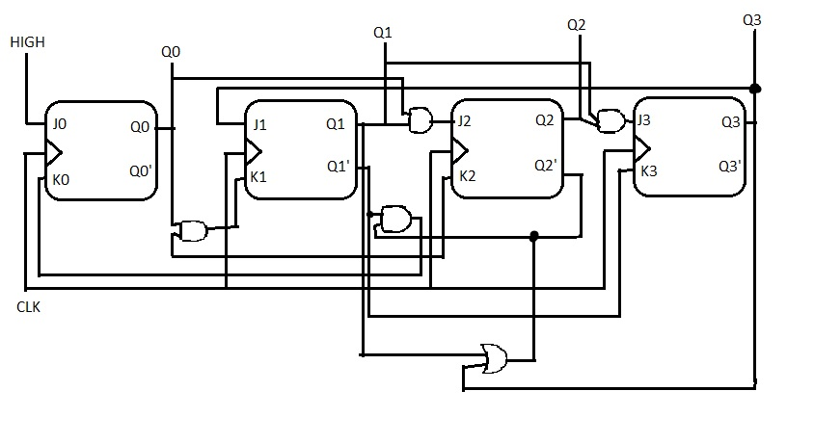

II. IMPLEMENTATION & DETAILS

Then by following our design, we implement our code as below;

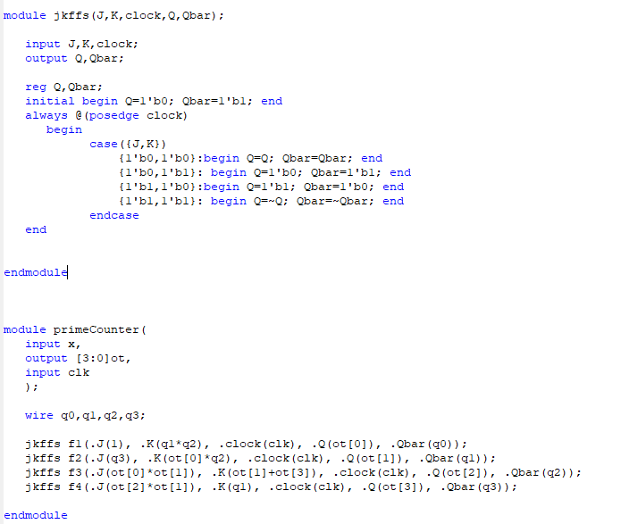

Actually f1’s should J(x) we have no time to change this.

X is high from our design schema.

- SAMPLE WAVEFORMS & TRUTH TABLE

We tried our code by test bench considering changes of clock(clk) values, it works correctly…

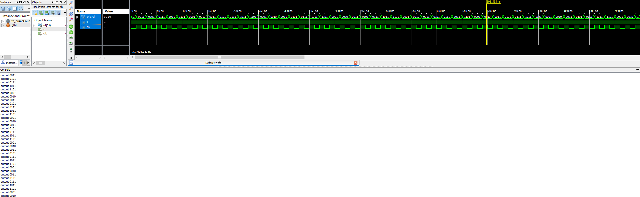

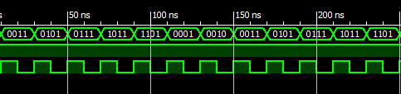

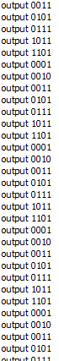

Kmaps

